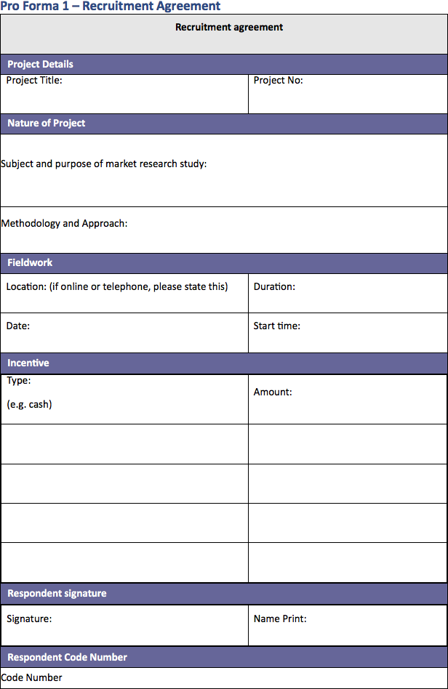

Pro Forma 2

Receipt of Incentive
Project Details
Project Title: | Project No:
Agency: | Agency Contact:
Fieldwork
Date of receipt: | Start Time:
Location: (If online or telephone, please state this) | Duration:
Incentive
Incentive Type: (e.g. cash) | Incentive Amount:
Declaration
I confirm that the information I have given during the course of this interview/group discussion represents my views on the subject matter.
I confirm that I have received the incentive detailed above in appreciation for my contribution to the project.
Market Research Subject Signature
Signature: | Name (please print)
Market Research Subject Code Number
Code Number

Pro Forma 3
Market Research Subject Consent Allowing Client Access to Market Research Fieldwork
Project Details
Project Title: | Project No:
Agency: | Location of Fieldwork:
Date of Fieldwork: | Start Time of Fieldwork:
Declaration
I understand that the company that commissioned this Market Research study
(name of recipient organisation(s) may or may not be required will:
DELETE AS APPROPRIATE
- Watch through a one way mirror (watching organisations do not need to be named) but type of organisation(s) should be specified
- Listen to an audio recording at their offices (organisations listening in may or may not need to be named depending on whether audio information is considered personal data or not)
- Watch a video recording at their offices (watching organisation(s) must be named but naming may be delayed until the end of the interview if viewing is not live)
I understand that the purpose(s) of the company having access is:
The people in the company who will listen to or view the recordings will be in the following functions/roles:
I understand that all those listening, watching or viewing the recording MUST respect the confidentiality of all information exchanged in Market Research interviews/groups and that no sales approaches will ever be made to me as a consequence of the company having this access.
I understand that I can withdraw my consent at any stage.
IF APPROPRIATE We would prefer not to reveal the name of the healthcare/pharmaceutical company until the end of the interview, just in case knowing this affects any responses. Is this acceptable to you or not? YES NO
Signatures
I have read, understand and agree to the terms above.
Market Research Subject Signature: | Name (please print)
Agency Signature: | Name (please print)
Market Research Subject Code Number
Code Number

Pro Forma 4
Client Agreement to Safeguard Confidentiality of Recordings of Market Research Fieldwork
Project Details
Project Title: | Project No:
Agency: | Location(s) of Fieldwork:
Date(s) of Fieldwork: | Start Time(s) of Fieldwork:
Commissioning Client Company
Declaration
On behalf of <the commissioning client company> I can confirm that the recording(s) of Market Research fieldwork from the above study will only be used for the following purpose(s):
The only people in the company who will listen to or view the recordings will be in the
following functions/roles:
And the recording(s) will be in the secure
care of:
On behalf of the commissioning client I can confirm that:
- Those listening to or viewing the recording will respect the confidentiality of all information exchanged in Market Research interviews/groups
- No sales approaches will ever be made to MR subjects as a consequence of having this access
- No attempt will be made to reverse any anonymisation
- The recordings will be stored securely, kept separate and processed in accordance with applicable data protection/privacy laws and Market Research professional codes
- The recordings will be destroyed or handed back to the agency as soon as is required.
- If video streaming has been used to allow remote viewing it is possible that the video transmission system used delivered a copy of the recording to the receiving computer. If this is the case any copy of the video stream saved on the observer’s computer MUST be deleted.
Signatures
I have read, understand and agree to the terms above
Company Signature: | Name (please print)
Agency Signature: | Name (please print)

Pro Forma 5
Observer Agreement
Project Details
Project Title: | Project No:
Agency: | Agency Contact:
Location of Fieldwork: | Date of Fieldwork:
 | Time of Fieldwork
Declaration
I understand that I MUST be familiar with and adhere to the EPHMRA’s Observers’ Guidelines.
Observer Signature
I have read, understand and agree to the terms
Signature: | Name (please print)

